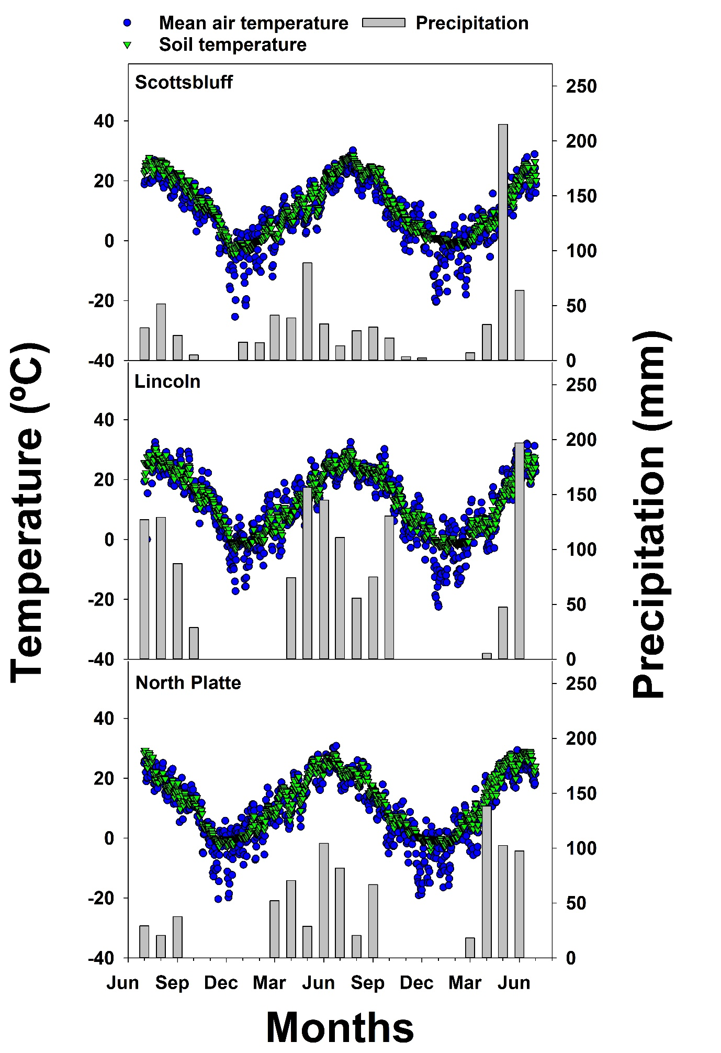

**Figure 1.** Mean air and soil temperatures and monthly mean precipitation of research sites (Scottsbluff, Lincoln, North Platte; NE, USA) during the growth period in 2016−2018.

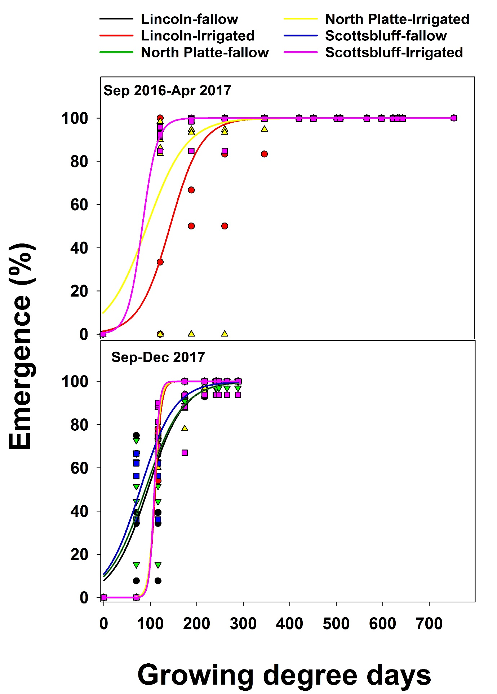**Figure 2.** The effect of seed accessions on *Erigeron canadensis* emergence for populations collected at Lincoln, North Platte and Scottsbluff, NE, USA at Scottsbluff research site. Estimated parameters are presented in Table 1.

|  |  |  |  |  |  |
| --- | --- | --- | --- | --- | --- |
| **Table 1**. A three-parameter sigmoidal model fitted to *Erigeron canadensis* emergencewhen emerge at different seed accessions at Scottsbluff research site. | | | | | |
| Populations | Field condition | Model parameters | | | |
| *b* | *X50* | *R2* | *RMSE* |
| Emergence (%) | | | |
| Sep 2016-Apr 2017 | | | | | |
| Lincoln | Irrigated | 33.55 (5.42) | 144.45 (5.58) | 0.85 | 108.09 |
| North Platte | Irrigated | 42.74 (8.39) | 94.71 (10.55) | 0.69 | 200.82 |
| Scottsbluff | Irrigated | 15.83 (3.59) | 84.71 (8.78) | 0.99 | 4.20 |
| Sep-Dec 2017 | | | | | |
| Lincoln | fallow | 38.50 (5.17) | 94.54 (5.73) | 0.86 | 160.82 |
| Lincoln | Irrigated | 16.65 (5.89) | 110.63 (5.27) | 0.99 | 11.36 |
| North Platte | fallow | 40.18 (4.62) | 89.44 (5.12) | 0.89 | 120.23 |
| North Platte | Irrigated | 16.40 (8.048) | 109.15 (9.35) | 0.98 | 24.33 |
| Scottsbluff | fallow | 37.17 (3.76) | 78.34 (4.03) | 0.92 | 77.72 |
| Scottsbluff | Irrigated | 18.34 (5.42) | 108.75 (26.44) | 0.97 | 31.63 |
| Values presented in the parentheses are standard errors of means.  *E = Xmax /[1+ exp (-(X-X50/ b)], F* is emergence (%) at GDD *X*, *Xmax* is the maximum emergence, *Xmax* =100%; *X50* is the GDDs required to reach a 50% emergence and *b* is the slope. | | | | | |

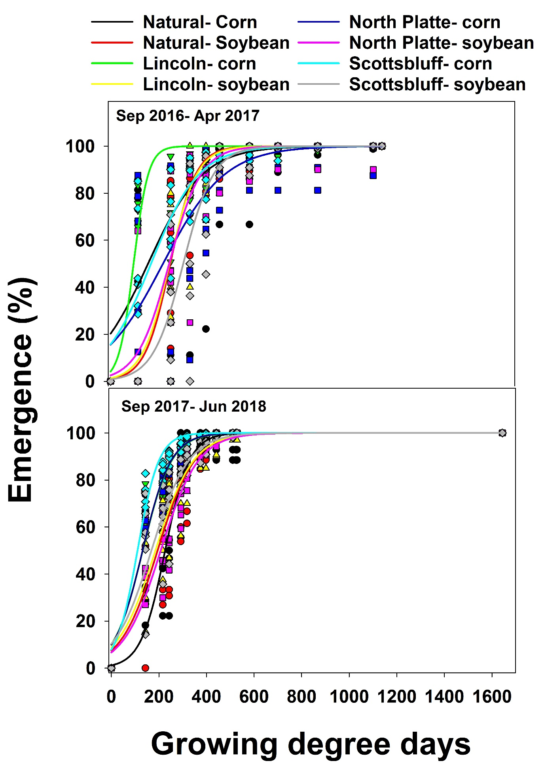

**Figure 2.** The effect of seed accessions on *Erigeron canadensis* emergence for populations collected at Lincoln, North Platte and Scottsbluff, NE, USA at Lincoln research site. Estimated parameters are presented in Table 1.

|  |  |  |  |  |  |
| --- | --- | --- | --- | --- | --- |
| **Table 2**. A three-parameter sigmoidal model fitted to *Erigeron canadensis* emergencewhen emerge at different seed accessions at Lincoln research site. | | | | | |
| Populations | Field condition | Model parameters | | | |
| *b* | *X50* | *R2* | *RMSE* |
| Emergence (%) | | | |
| Sep 2016-Apr 2017 | | | | | |
| Natural | Corn | 114.88 (21.48) | 157.35 (24.59) | 0.63 | 427.05 |
| Natural | Soybean | 53.57 (7.01) | 250.80 (7.72) | 0.93 | 102.84 |
| Lincoln | Corn | 30.88 (9.17) | 96.76 (7.39) | 0.87 | 118.85 |
| Lincoln | Soybean | 57.16 (6.93) | 247.58 (7.87) | 0.93 | 98.05 |
| North Platte | Corn | 130.20 (23.67) | 220.32 (25.50) | 0.65 | 451.59 |
| North Platte | Soybean | 67.40 (9.46) | 246.11 (11.14) | 0.88 | 168.08 |
| Scottsbluff | Corn | 101.18 (11.26) | 169.83 (13.47) | 0.85 | 149.51 |
| Scottsbluff | Soybean | 63.93 (10.07) | 305.33 (10.70) | 0.88 | 212.73 |
| Sep 2017-Jun 2018 | | | | | |
| Natural | Corn | 50.79 (4.68) | 226.24 (4.76) | 0.92 | 91.07 |
| Natural | Soybean | 77.24 (9.18) | 194.51 (9.845) | 0.83 | 181.40 |
| Lincoln | Corn | 60.39 (3.56) | 131.95 (4.58) | 0.96 | 30.37 |
| Lincoln | Soybean | 79.63 (6.38) | 185.33 (6.99) | 0.91 | 82.48 |
| North Platte | Corn | 59.74 (3.37) | 131.60 (4.34) | 0.96 | 27.38 |
| North Platte | Soybean | 78.65 (5.17) | 207.65 (5.40) | 0.94 | 58.86 |
| Scottsbluff | Corn | 44.75 (2.83) | 110.13 (3.92) | 0.97 | 20.57 |
| Scottsbluff | Soybean | 78.01 (6.26) | 168.48 (7.17) | 0.91 | 78.15 |
| Values presented in the parentheses are standard errors of means.  *E = Xmax /[1+ exp (-(X-X50/ b)], F* is emergence (%) at GDD *X*, *Xmax* is the maximum emergence, *Xmax* =100%; *X50* is the GDDs required to reach a 50% emergence and *b* is the slope. | | | | | |

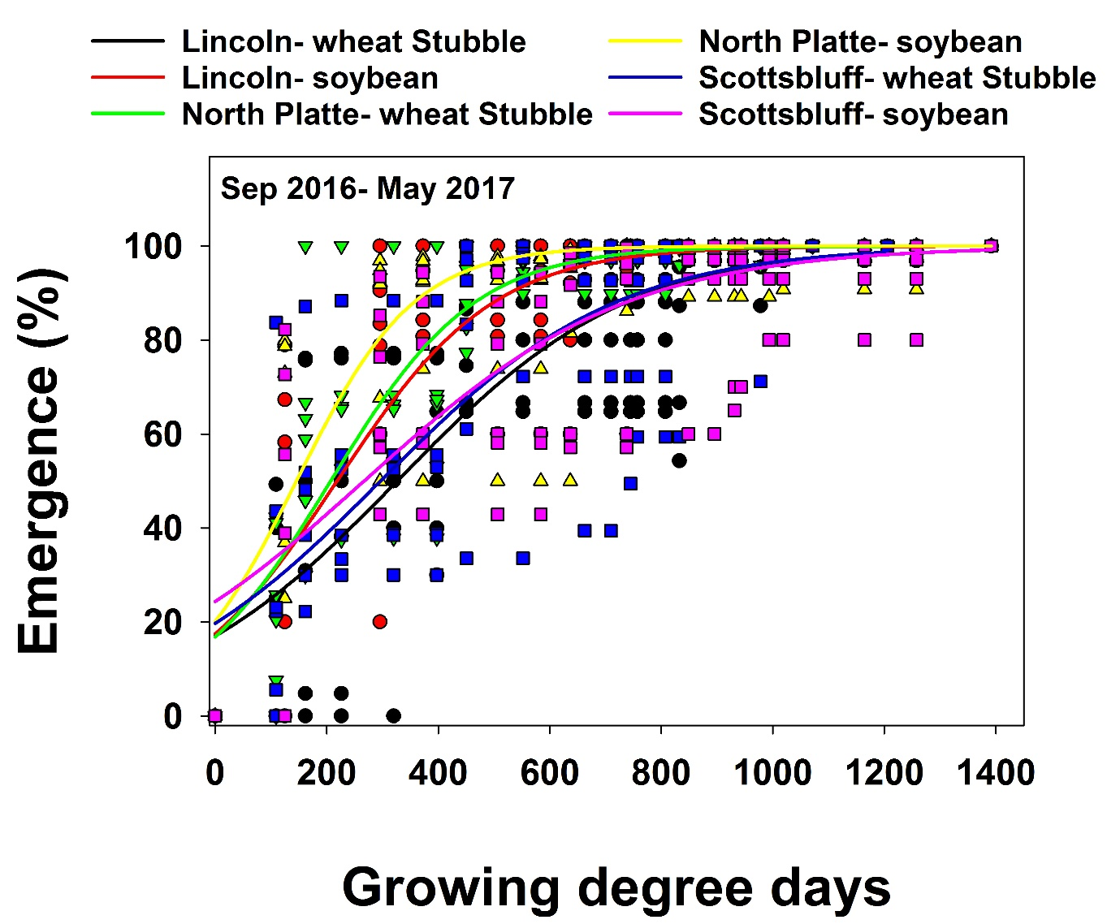

**Figure 2.** The effect of seed accessions on *Erigeron canadensis* emergence for populations collected at Lincoln, North Platte and Scottsbluff, NE, USA at North Platte research site. Estimated parameters are presented in Table 1.

|  |  |  |  |  |  |
| --- | --- | --- | --- | --- | --- |
| **Table 3**. A three-parameter sigmoidal model fitted to *Erigeron canadensis* emergencewhen emerge at different seed accessions at North Platte research site. | | | | | |
| Populations | Field condition | Model parameters | | | |
| *b* | *X50* | *R2* | *RMSE* |
| Emergence (%) | | | |
| Sep 2016-May 2017 | | | | | |
| Lincoln | Wheat Stubble | 205.97 (23.02) | 326.53 (24.17) | 0.69 | 345.10 |
| Lincoln | Soybean | 140.70 (17.05) | 218.66 (19.62) | 0.76 | 197.82 |
| North Platte | Wheat Stubble | 129.53 (207.23) | 207.23 (13.89) | 0.80 | 184.89 |
| North Platte | Soybean | 105.65 (15.54) | 145.78 (17.76) | 0.70 | 205.41 |
| Scottsbluff | Wheat Stubble | 211.01 (25.82) | 296.57 (26.54) | 0.64 | 389.41 |
| Scottsbluff | Soybean | 235.32 (28.83) | 267.08 (32.33) | 304.29 | 304.29 |
| Values presented in the parentheses are standard errors of means.  *E = Xmax /[1+ exp (-(X-X50/ b)], F* is emergence (%) at GDD *X*, *Xmax* is the maximum emergence, *Xmax* =100%; *X50* is the GDDs required to reach a 50% emergence and *b* is the slope. | | | | | |